Fall 2021-2022
CSE3001: Software Engineering
J Component Review 2
Advait Deochakke – 20BCE1143

Partial Implementation of J Component
------------------------------------------------------------------------------------------

Billing

Initial State

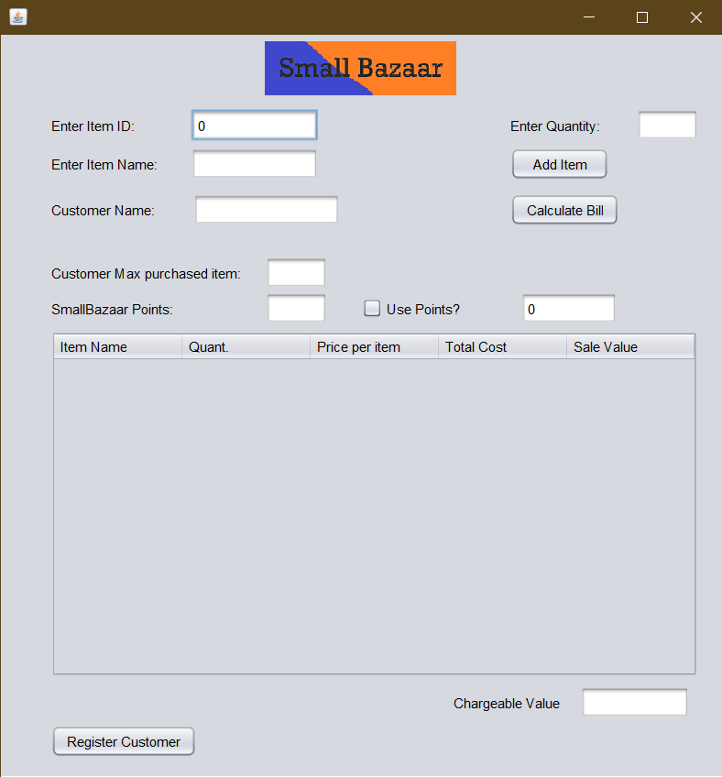

Adding 3 quantity of item 2
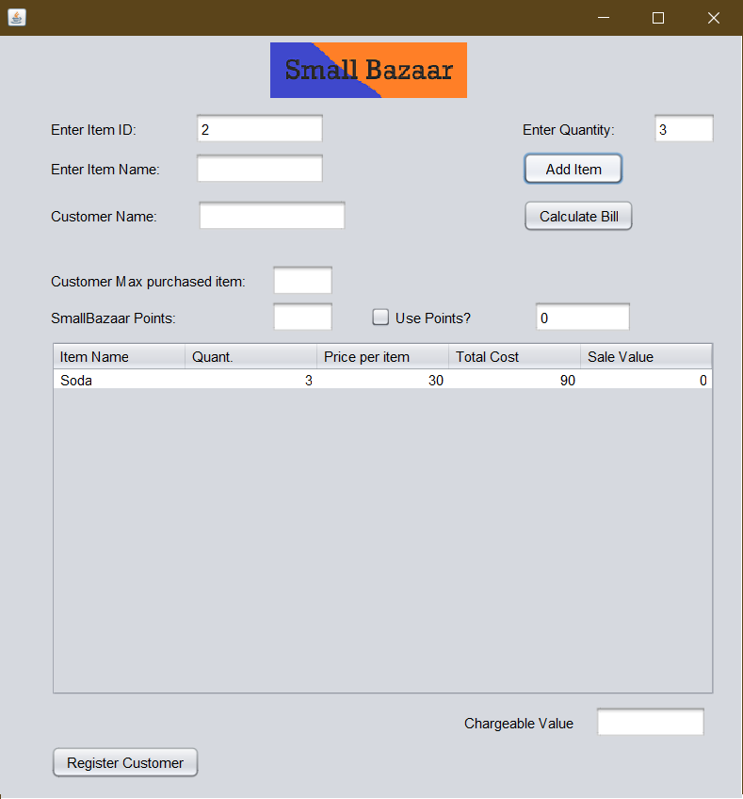

Adding 1 quantity of item Chips
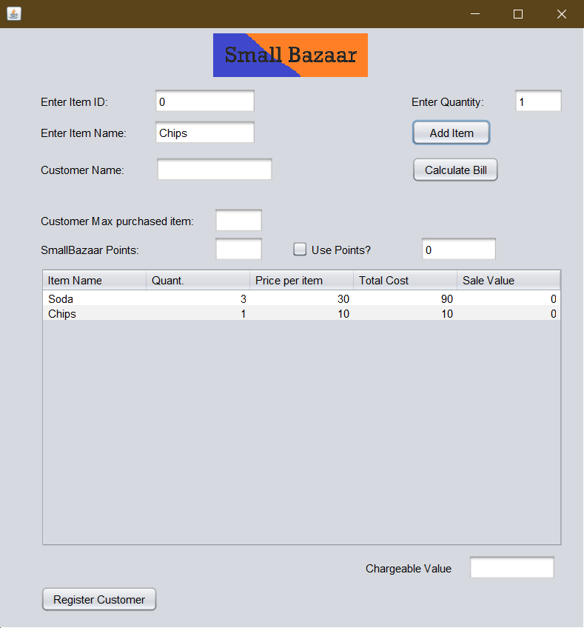

Calculating Bill no sale no points used

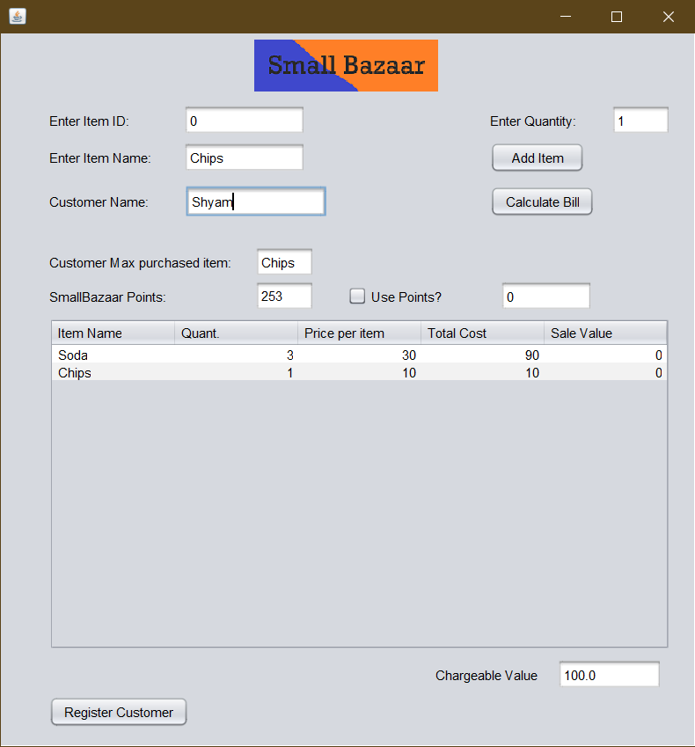

Calculating Bill no sale but 10 points used
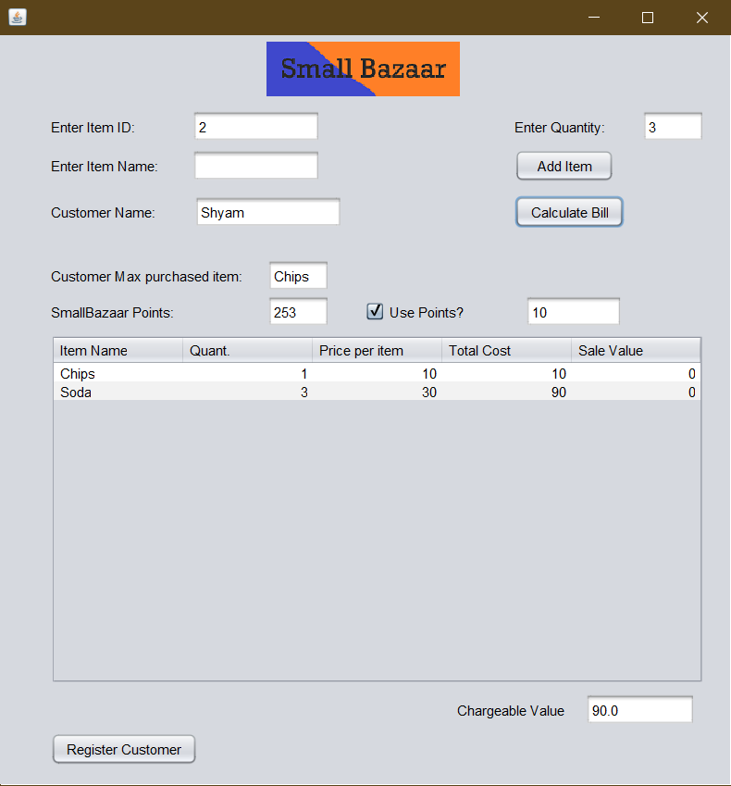

Updated database for points after points discount

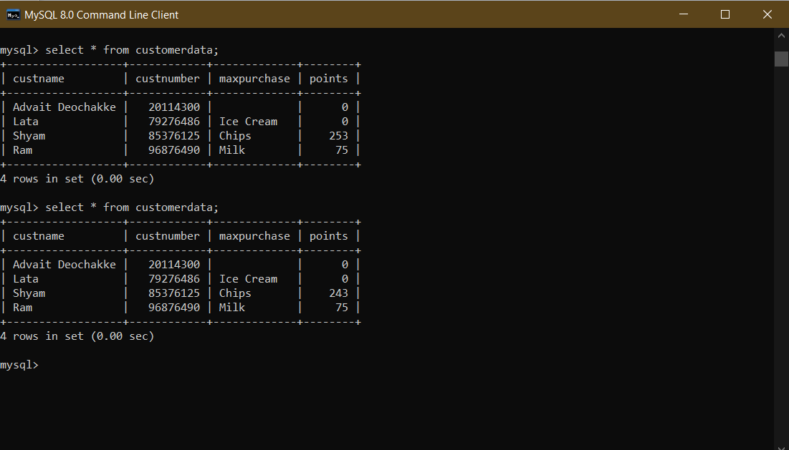

Calculating Bill both sale and points used

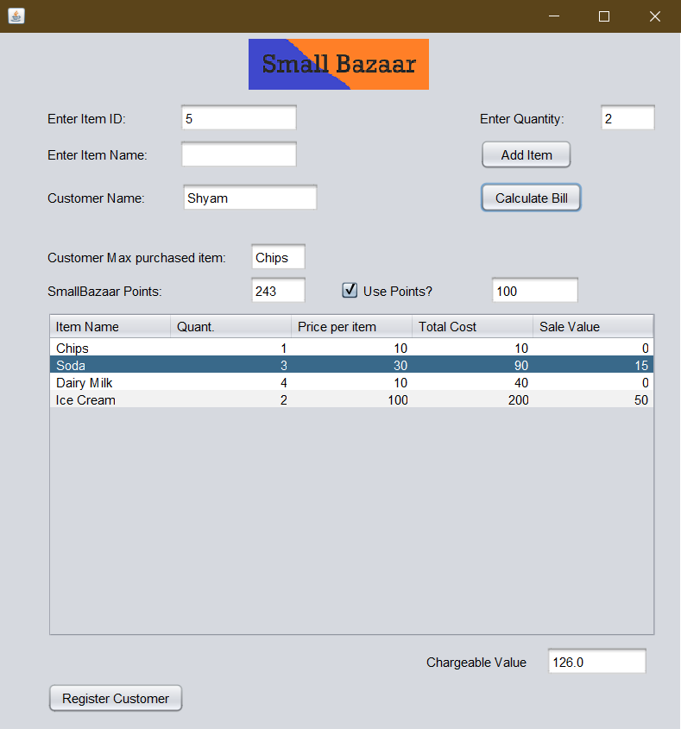

Updated database for points after sale and points discount

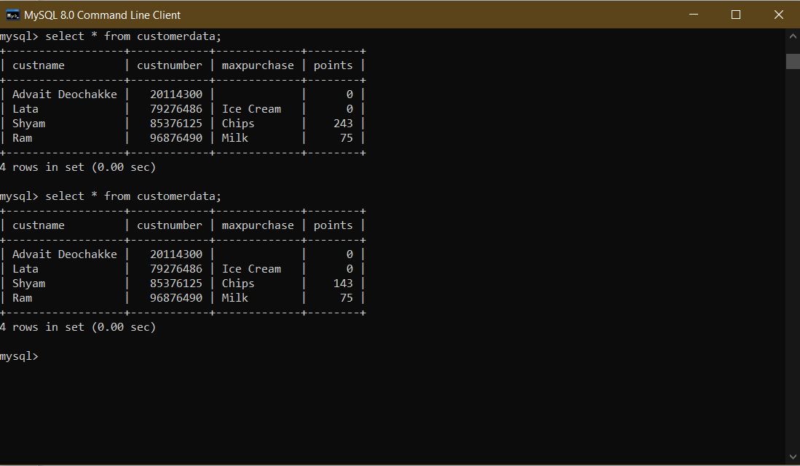

------------------------------------------------------------------------------------------

Registration

(On clicking the “Register Customer” Button on bottom left of Billing screen. Exits Billing window and opens Registration window)

Register_Customer

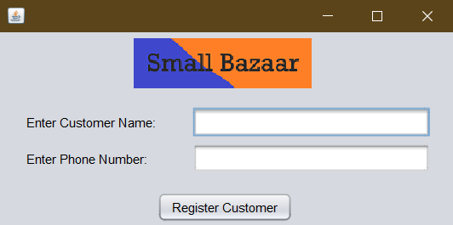

Register_Customer_2

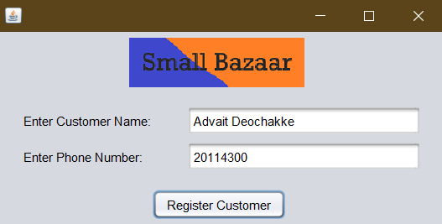

Before and After Customer Registration




